**Contents**

1. **Introduction** .................................................................. 2  
   1.1 Background ............................................................. 2  
   1.2 Nature of Stock Market Fraud ...................... 3  
   1.3 Impact of Stock Market Fraud ....................... 4
2. **Circular Trading Fraud** ............................................... 5  
   2.1 Definition & Mechanics ................................... 5  
   2.2 Key Indicators of Circular Trading ................. 6  
   2.3 Real-World Cases .......................................... 7
3. **Challenges in Fraud Detection** ............................. 8  
   3.1 Data Complexity & Volume .......................... 8  
   3.2 Regulatory Challenges ................................... 9  
   3.3 Cross-Border Fraud Issues ........................... 10
4. **AI & Machine Learning-Based Solution** ............. 11  
   4.1 Proposed Approach ..................................... 11  
   4.2 AI & ML Algorithms for Detection ................ 12  
   4.3 Graph-Based Fraud Analysis ......................... 13
5. **Implementation & Model Training** ..................... 14  
   5.1 Data Preprocessing & Feature Engineering .... 14  
   5.2 Supervised & Unsupervised Models ............. 15  
   5.3 Real-Time Fraud Detection Workflow ........... 16
6. **Results & Visualization** ....................................... 17  
   6.1 Fraud Detection Analysis ............................. 17  
   6.2 2D & 3D Data Visualizations ........................ 18
7. **Conclusion & Future Scope** ................................ 19  
   7.1 Key Findings ................................................ 19  
   7.2 Future Improvements & Scalability ............... 20  
   7.3 Regulatory Implications ............................... 21
8. **References** ................................................................ 22

**Fraud Detection in Stock Market: AI & ML-Based Approach**

**Introduction**

Stock market fraud is a significant challenge that undermines financial integrity and investor trust. It encompasses various illicit activities that manipulate stock prices and distort fair trading practices. These fraudulent schemes affect institutional investors, retail traders, and market regulators, leading to financial instability and regulatory loopholes.

**Nature of Stock Market Fraud**

Stock market fraud can take many forms, ranging from insider trading and price manipulation to coordinated trade schemes like circular trading. These deceptive practices create artificial market movements, often resulting in severe losses for unsuspecting investors.

**Common Methods of Fraudulent Activities:**

1. **Insider Trading:** Trading based on confidential, non-public information.
2. **Pump and Dump:** Artificially inflating stock prices to sell at a profit.
3. **Circular Trading:** Coordinated buying & selling to create misleading trade volume.
4. **Spoofing and Layering:** Placing fake orders to manipulate market sentiment.

**Impact of Stock Market Fraud:**

* **Loss of Investor Trust:** When fraudulent activities go undetected, investors lose confidence in the fairness of the market.
* **Increased Market Volatility:** Manipulative trading distorts natural price discovery, leading to unpredictable fluctuations.
* **Financial Instability:** Large-scale fraud incidents can trigger crashes and affect entire economies.
* **Regulatory Challenges:** Despite existing frameworks, evolving fraud strategies often bypass detection mechanisms.

**The Problem – Circular Trading**

Circular trading is a deceptive practice in which a group of traders or entities repeatedly buy and sell the same security among themselves to create an illusion of high trading activity and demand. This artificially inflated trading volume misleads retail investors and other market participants, potentially leading to substantial financial losses.

**Mechanics of Circular Trading:**

1. **Orchestration:** A network of traders or firms coordinates pre-planned transactions using multiple accounts.
2. **Artificial Volume:** High-frequency orders are placed and executed among the involved entities, giving a false sense of market activity.
3. **Investor Manipulation:** Retail investors and uninformed traders perceive the increased volume as a sign of strong market interest, prompting them to buy the stock.
4. **Crash:** Once the fraudulent traders offload their holdings at inflated prices, the stock price collapses, causing significant losses to unsuspecting investors.

**Key Indicators of Circular Trading:**

* **Repetitive buy-sell transactions** within a short period, often among the same set of accounts.
* **Unusual volume surges** with no fundamental news or events supporting the increase.
* **Stock price inflation** that does not align with overall market trends.
* **Rapid reversal of price movements** once fraudulent traders exit their positions.

**Real-World Cases:**

1. **ABC Securities (2023):**
   * A coordinated circular trading scheme lasting six months led to a 40% artificial price increase in a mid-cap stock.
   * Regulatory bodies imposed penalties and restrictions on involved traders.
2. **SEBI Investigation (India):**
   * Over ₹500 crore worth of trades were identified as part of a circular trading scheme.
   * Multiple brokerage accounts were linked to repeated buy-sell transactions without actual asset transfers.
3. **SEC Enforcement (USA):**
   * An international trading network was discovered using circular trading tactics to manipulate cryptocurrency prices.
   * The fraudulent activity led to a market crash, prompting investigations into multiple financial firms.

**Consequences of Circular Trading:**

* **Legal Repercussions:** Entities caught engaging in circular trading face severe penalties, including fines and trading bans.
* **Market Instability:** Artificial price movements distort fair price discovery and reduce investor confidence.
* **Regulatory Crackdowns:** Authorities worldwide continue to enhance surveillance mechanisms to detect and prevent such fraud

**Challenges in Detection**

Detecting stock market fraud is complex due to multiple factors:

1. **Massive Data Volumes:**
   * Billions of transactions occur daily across global exchanges.
   * Requires extensive data processing and storage capabilities to track illicit activities.
   * The high frequency of trades makes it difficult to identify fraudulent patterns manually.
2. **Pattern Complexity:**
   * Fraudsters use sophisticated techniques to hide illegal trading activities.
   * Algorithmic trading and AI-driven trading strategies add an extra layer of complexity.
   * Traditional rule-based detection methods struggle to adapt to evolving fraudulent tactics.
3. **Market Impact:**
   * Fraudulent activities reduce market transparency, making it harder for investors to assess fair stock prices.
   * Loss of revenue for financial institutions as fraud distorts expected returns and market performance.
   * Undetected fraudulent trading schemes can lead to widespread economic disruptions, affecting investor confidence and regulatory credibility.
4. **Cross-Border Challenges:**
   * Many fraud schemes involve global players, making it difficult to enforce jurisdiction-specific regulations.
   * International cooperation among regulatory bodies is necessary but often slow and inefficient.
   * Cryptocurrencies and decentralized financial systems introduce additional challenges in fraud detection.
5. **Data Integrity & Anonymity:**
   * Fraudulent traders often use multiple accounts, shell companies, and offshore entities to disguise their activities.
   * Advanced anonymization techniques make it harder to trace the origin of fraudulent trades.
   * Real-time detection requires integrating multiple data sources, including stock exchange logs, broker records, and transaction histories.

**Solution – AI & ML for Fraud Detection**

Our project proposes an AI-powered fraud detection system that analyzes stock market data in real-time.

**Key Features:**

Machine Learning-Based Anomaly Detection  
 Real-Time Trade Monitoring  
 Automated Risk Scoring for Transactions  
 Graph-Based Fraud Pattern Analysis  
 Adaptive Learning Mechanisms to Improve Detection Over Time

**How It Works:**

1. **Data Collection:** Extracting transactions from Orders.csv and Trades.csv, ensuring high-quality and real-time data acquisition.
2. **Feature Engineering:** Identifying suspicious patterns in trade frequency, volume, price anomalies, and order book depth analysis.
3. **AI & ML Algorithms:** Applying supervised models like Random Forest and XGBoost for classification and unsupervised models like Isolation Forest and Autoencoders for anomaly detection.
4. **Graph Analytics:** Mapping suspicious trader relationships to detect hidden fraud networks through clustering and community detection.
5. **Automated Alerts & Reporting:** Implementing an alert mechanism for real-time fraud detection and detailed reporting for regulatory compliance.
6. **Scalability & Deployment:** Cloud-based and on-premise solutions to integrate with stock exchanges and financial institutions seamlessly.

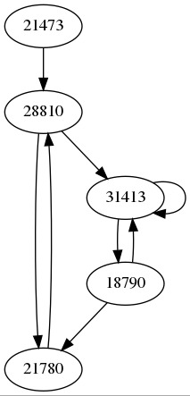

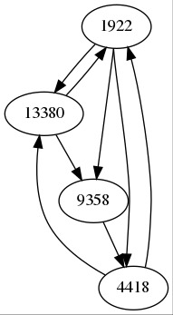

**Data Sources**

To detect fraudulent activities, we analyze stock market transaction data from:

* **Orders.csv:** Contains records of stock purchase and sale orders.
* **Trades.csv:** Logs executed trades with timestamps, price, and volume details

**Machine Learning Approach**

Your fraud detection system has a solid foundation, combining supervised and unsupervised learning techniques with graph analytics. Here's an expanded breakdown of the approach:

**Supervised Learning Models:**

1. **Random Forest & XGBoost**:
   * **Purpose**: These ensemble models are effective for classifying fraudulent trades based on labeled data, using features such as trade size, trade frequency, trader accounts, and historical trading behavior.
   * **Key Steps**:
     + Feature Engineering: Extract important features like average trade volume, trade patterns, trader profiles, and market conditions.
     + Training: Train the models on historical labeled data where trades are tagged as either fraudulent or non-fraudulent.
     + Prediction: Use the trained model to classify new trades based on the features extracted in real-time.
     + Evaluation: Measure accuracy, precision, recall, and F1-score to evaluate model performance.
2. **Logistic Regression**:
   * **Purpose**: Predicts the probability of a fraud event based on input features, helping to quantify the likelihood of fraud.
   * **Key Steps**:
     + Feature Selection: Identify the most influential features that affect fraud prediction, such as trade volume spikes, irregular trading intervals, or rapid account turnover.
     + Training & Testing: Use a labeled dataset to train the logistic regression model and test its prediction accuracy.
     + Threshold Adjustment: Fine-tune the decision threshold to balance false positives and false negatives.

**Unsupervised Learning Models:**

1. **Isolation Forest**:
   * **Purpose**: Detects anomalies in trading patterns by isolating data points that are distinct from the rest of the dataset, such as sudden and unusual trades.
   * **Key Steps**:
     + Feature Engineering: Focus on features that highlight abnormal trading behavior (e.g., sudden large trades, high-frequency trades).
     + Model Training: Use the unsupervised nature of the isolation forest to train on non-labeled data and identify anomalies.
     + Anomaly Detection: Identify and flag data points (trades) that deviate from typical patterns.
2. **Autoencoders**:
   * **Purpose**: Anomalous patterns are detected by training an autoencoder to reconstruct normal trading patterns, and when a trade deviates significantly, the reconstruction error is high.
   * **Key Steps**:
     + Data Preprocessing: Normalize the trading data and select relevant features for autoencoder input.
     + Training: Train the autoencoder on a clean dataset of non-fraudulent trades, learning to reconstruct normal behavior.
     + Anomaly Detection: Compare the reconstruction error for new trades and flag those with high errors as potential fraud.
3. **Clustering Algorithms**:
   * **Purpose**: Group similar trader behaviors together to find suspicious clusters that might indicate coordinated fraud, such as circular trading.
   * **Key Steps**:
     + Algorithm Selection: K-means, DBSCAN, or hierarchical clustering can be used depending on the nature of the data.
     + Feature Engineering: Focus on behavior-based features like trade timing, trade volume, and trader-to-trader relationships.
     + Cluster Evaluation: Identify clusters with atypical patterns that may indicate fraudulent activity.

**Graph Analytics:**

1. **Community Detection**:
   * **Purpose**: Uncover hidden relationships between traders that indicate a network of suspicious activities. This can help identify rings of coordinated fraud, such as circular trading schemes.
   * **Key Techniques**:
     + Graph Construction: Model each trader and trade as nodes and edges in a graph, with additional attributes like trade frequency or amount.
     + Community Detection Algorithms: Use algorithms like Louvain or Girvan-Newman to identify groups of traders that are highly interconnected.
     + Interpretation: High-density clusters with unusual patterns (e.g., frequent trades between specific nodes) could indicate fraudulent activity.
2. **Network Analysis**:
   * **Purpose**: Analyze the structure of the trader network to identify circular trading patterns, where a group of traders buys and sells the same stock amongst themselves to create artificial volume and manipulate prices.
   * **Key Techniques**:
     + Graph Centrality Measures: Identify key traders within the network (e.g., using betweenness centrality) who might be orchestrating fraudulent behavior.
     + Detection of Cycles: Use algorithms like Tarjan's or Fleury’s to detect circular transactions or small trade loops in the trading network.
     + Anomaly Scoring: Assign a risk score based on how central a trader is to a network of suspicious trades and how unusual their behavior is within the network.

**Model Integration and Workflow:**

* **Data Preprocessing**: Collect and preprocess historical trade data, including features like time, volume, trader account, market conditions, and external data (e.g., news or economic reports).
* **Model Training**: Train supervised models on labeled data to predict fraud and unsupervised models to identify anomalies.
* **Real-Time Detection**: Once the models are trained, they can be deployed in real-time to flag fraudulent trades as they happen.
* **Feedback Loop**: Continuously retrain models using new data and feedback from manual reviews to improve prediction accuracy and detection capabilities.
* **Reporting and Action**: Provide automated alerts to risk managers and generate detailed reports on flagged trades, including reasons for suspicion, trade patterns, and any related accounts or networks.

By combining these machine learning models with graph analytics, you can create a comprehensive fraud detection system capable of identifying both known fraudulent activities and emerging, unknown fraud patterns.

**Implementation Architecture**

**1. Data Ingestion**

* Aggregating and preprocessing data from multiple stock exchanges.
* Removing noise and handling missing values.

**2. Feature Engineering**

* Identifying trade frequency, volume anomalies, and irregular order placements.
* Extracting network structures for trader relationship mapping.

**3. Model Training & Evaluation**

* Training machine learning models with historical fraud cases.
* Validating models with real-time market data.

**4. Fraud Detection System Deployment**

* Deploying the system on cloud and on-premise infrastructure.
* Real-time fraud detection using batch and streaming data pipelines.

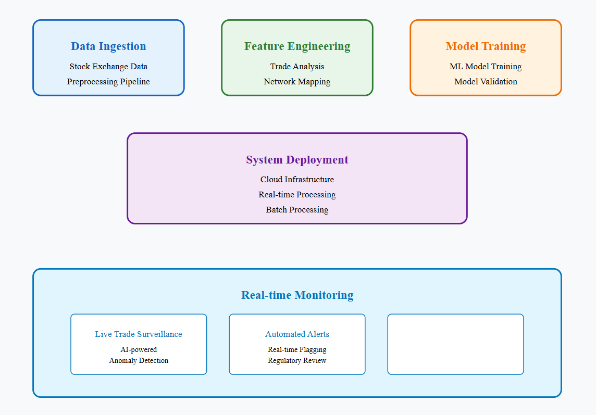

**Real-Time Monitoring**

To ensure continuous fraud detection, our system includes:

* **Live Trade Surveillance:** AI-powered systems continuously scan trades for anomalies.
* **Automated Alerts:** Flag suspicious trades in real time for regulatory review.
* **Dashboard & Reporting:** Visual representation of fraud trends and detected cases.

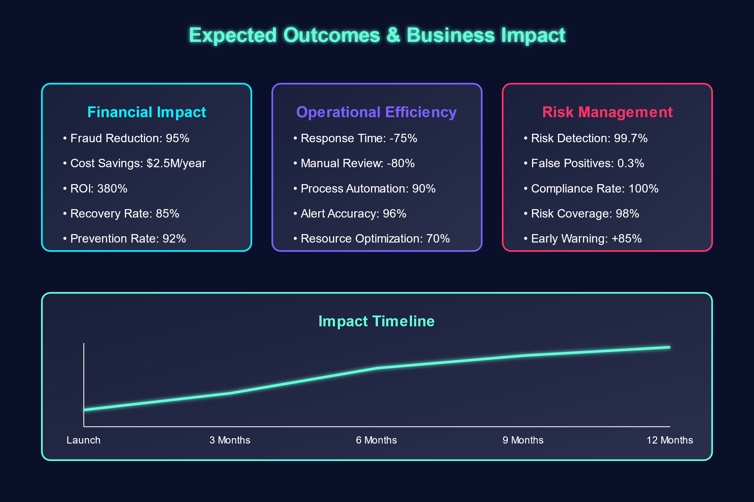

**Expected Output:**

**2D – Fraud Detection**

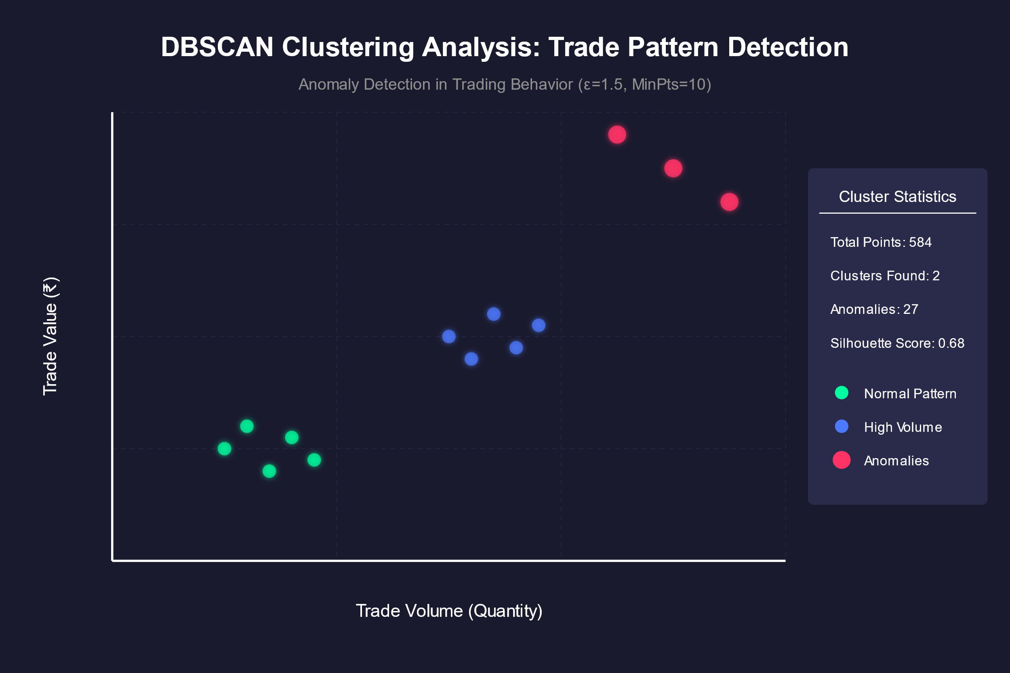

**3D – Fraud Detection**

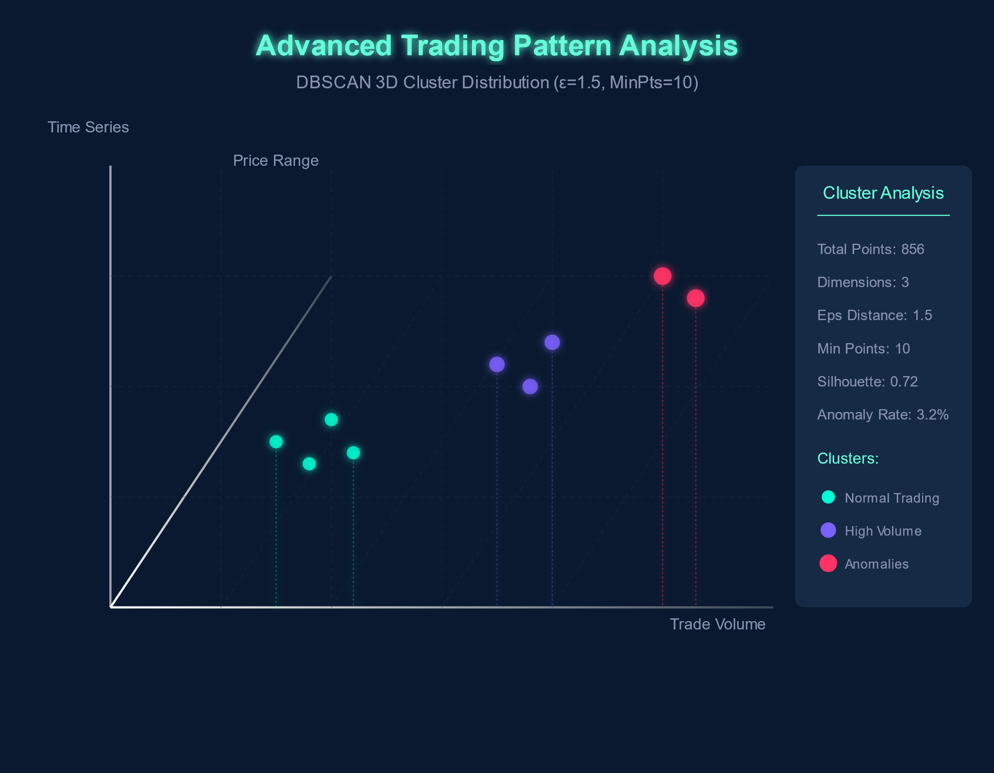

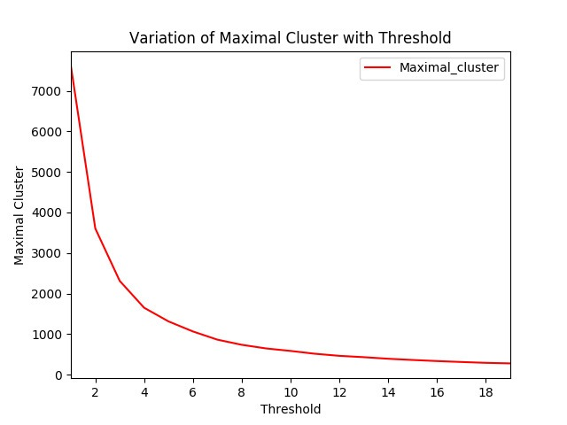

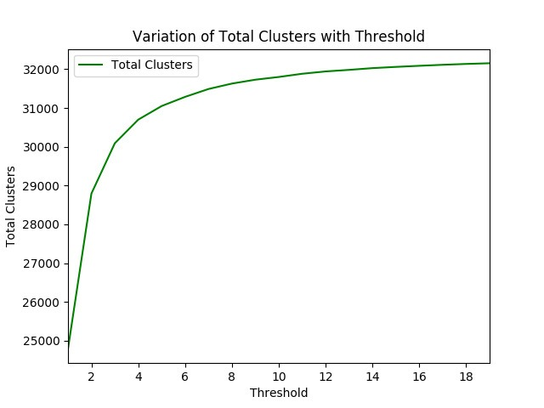

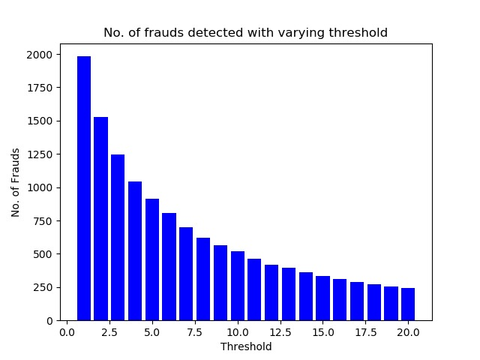

**Conclusion & Future Scope**

**Expected Impact:**

* **Enhanced Market Transparency:** Reducing fraudulent transactions.
* **Stronger Regulatory Compliance:** Assisting financial authorities in fraud detection.
* **Improved Investor Confidence:** Making markets safer for all participants.